**INTELLIGENT ADMISSIONS-THE FUTURE OF UNIVERSITY**

**By**

**TEAM LEADER: PAVITHRA.K**

**TEAM MEMBERS:**

**PAVITHRA.K**

**PRIYA.C**

**RENUGAMBAL.N**

**REPORT**

**Introduction**

* 1. **Overview**

Our project is Admission predict using machine learning this topic says about the admissions in our day-today life for example : Admissions in hospital,Admissions in college and etc…, we will have an subheadings of

1.GRE Score

2. TOEFL Score

3. University

4. SOP

5. LOR

6. CGPA

7. Research

8. Chance of Admit

* 1. **purpose**

The aim of this project is to help students in short listing universities with their profiles.Machine learning algorithms are then used to train a model on this data,which can be used to predict the chances of future applicants being admitted.

With this project students can make more informed decisions about which universities to apply to,and universities can make more efficient use of their resources by focusing on the most promising applicants.

**Problem definition & design timing**

**2.1 Empathy map**

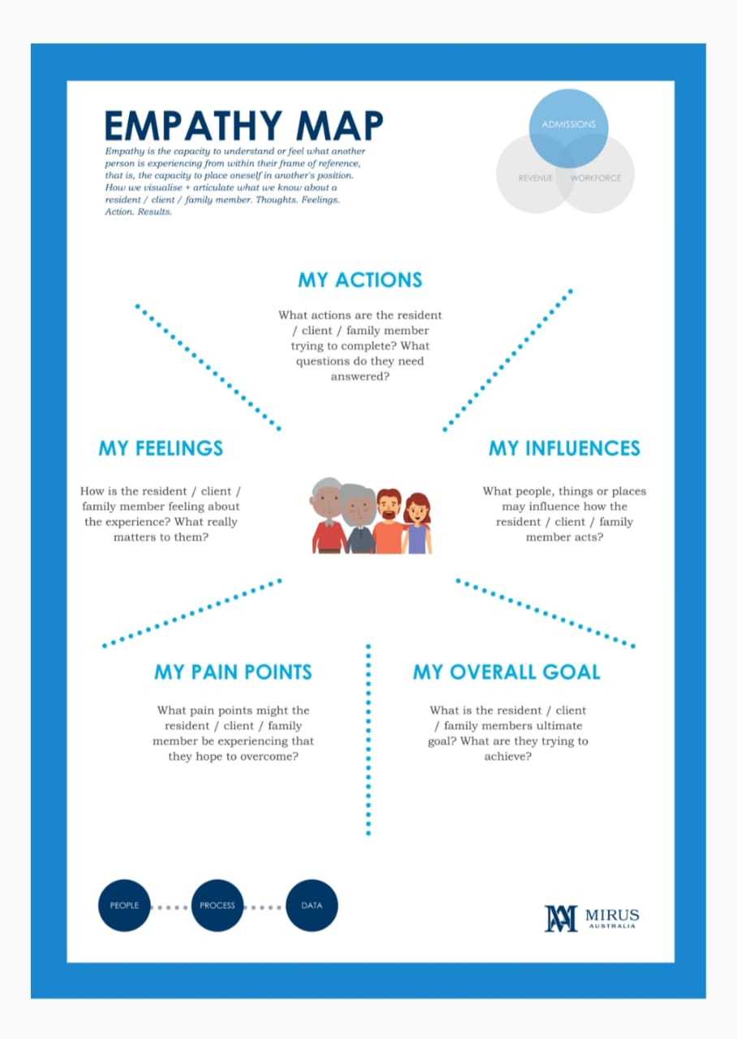

**2.2 ideation &brainstorming map**

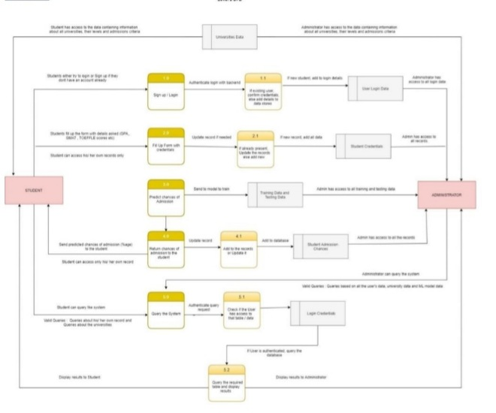

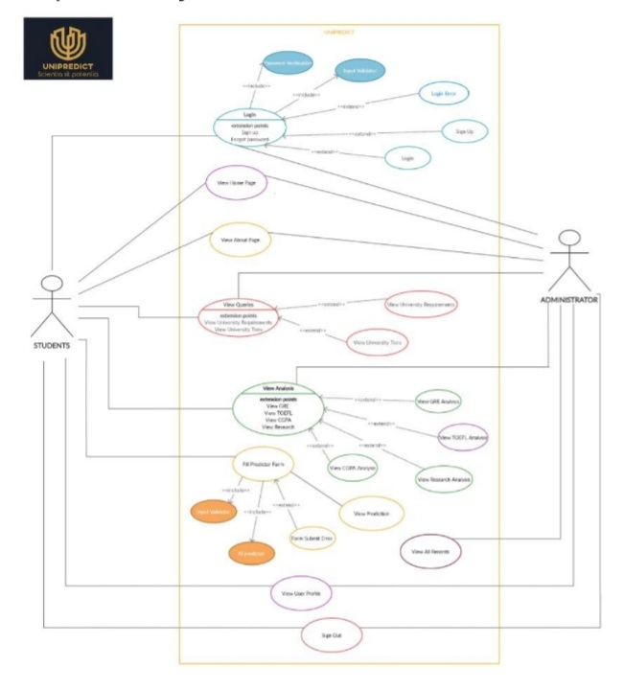

**Result**

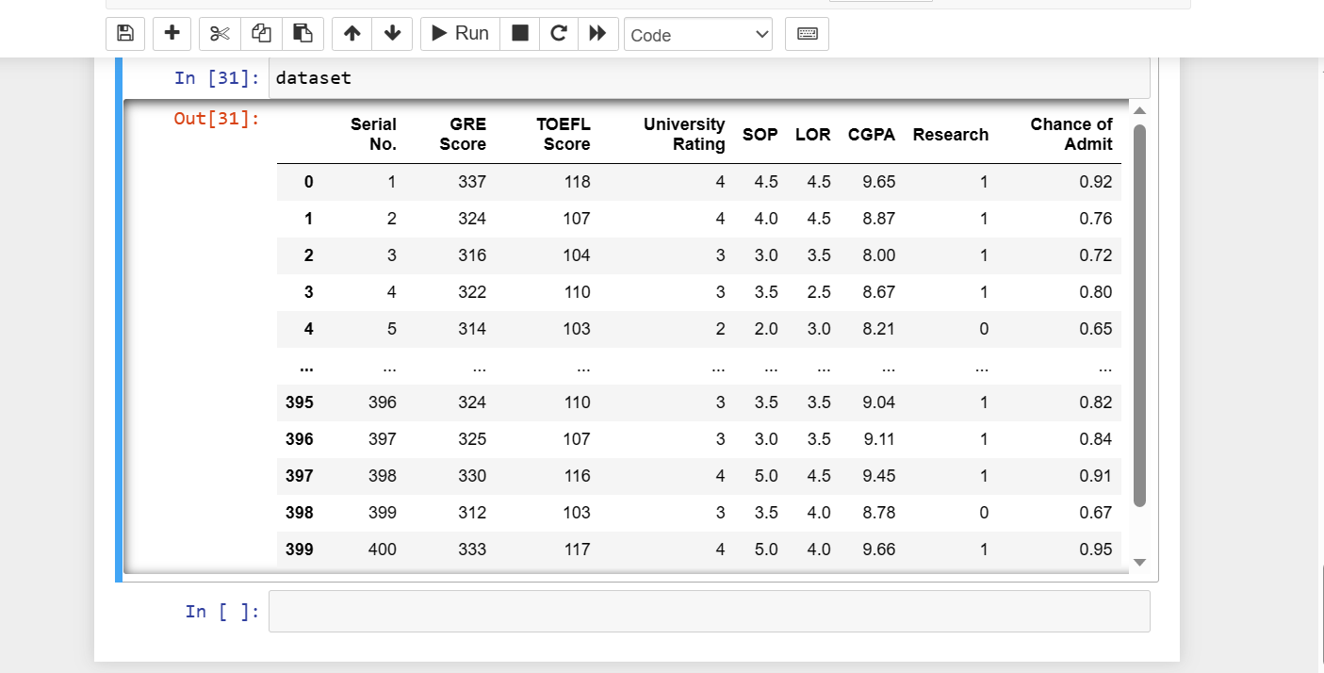

**Advantage and disadvantage**

ADVANTAGE :

* It helps students for making decision for choosing a right college.
* Here the chance of occurrence of error is less when compared with the existing system.
* It is fast ,efficient and reliable.
* Avoids data redundancy and inconsistency.
* Very user-friendly.
* Easy accessibility of data.

DISADVANTAGE :

* Required active internet connection.
* System will provide inaccurate results if data entered incorrectly.

**Application**

To start we need collaborative ,industry-wide commitment to more equitable and exclusive admissions policies and practice. At the gathering ,teams imagined cross-cutting solutions as key to improving the admissions process, hanging on a collaborative approach action approach to change.

**Conclusion**

We conclude by suggest that the future of universities will be taking a crucial and leading role within a goverencemiliel of many collaborating public and private agencies and organisation to be more inclusive ,reflective and restorative organisation.

**Future scope**

There is one segment named lab unit needed computer system to improve work. In this system, we tried to make a simple application for user. We can change our system day by day as per user requirements will be changed .In future ,we want to implement below point in our system.

* We can generate student attendance report.
* We can generate graphical report of students result.

**Appendix**

